#think crazy @ youtube (shambhavi chaudhary)

I have always had a zeal for acting and have pursued my passion for theatre and acting right from my school days till now. The college’s drama club, GAP has taught me a lot and has also taken away my fear of showcasing my talent in front of the world. I used to have the fears of failure and so never dared to work on making something funny and entertaining with my talent. Having won around 10-12 skits, street and one act plays in 2 years of college ,it was only last year, in may when I uploaded my first video(which I never was to upload) and in a day it crossed 1000 views and I began to feel that it’s going pretty well.

Struggling to manage time with the busy schedule of the college, GAP, NGO and projects I somehow tried to keep uploading more videos and the subscribers rose to 300 in 6 months with 5 videos. Finally in December 2016 I was recognized by a short film producer Mr.Prakash (CREATIVE VISION STUIDOS) who offered me the lead role in his upcoming short film “THE WEEKEND “. Now the film has been sent to the INTERNATIONAL SHORT FILM FESTIVAL and the results are due.

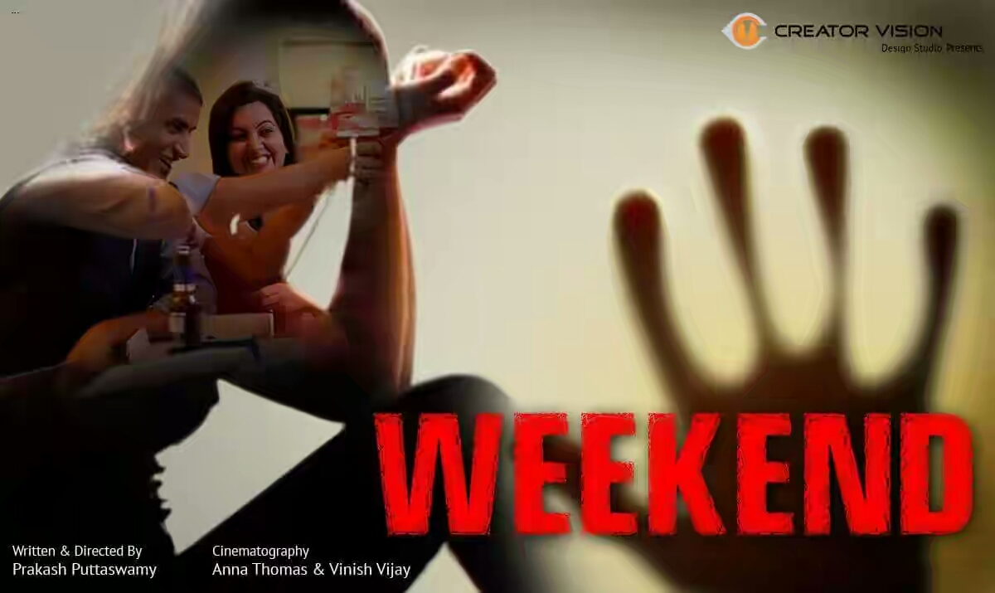

8 months after the release of the first video PINKIYA KE MUMMY was uploaded, it became viral in the northern parts of INDIA and it was seen and put up on all social media and I started getting a lot of support and appreciation from people. It’s an awesome feeling to be living your dream and chasing it each day. I hope I keep going with this creation of mine. I would like to tell everyone to keep following your dreams else you will end up living a life half lived or just survived.



**channel’s preview in august last year**

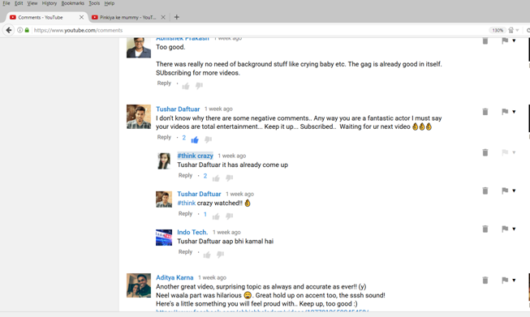

**comments from all over india**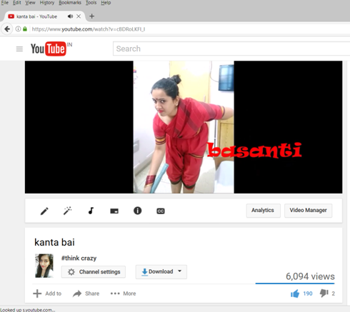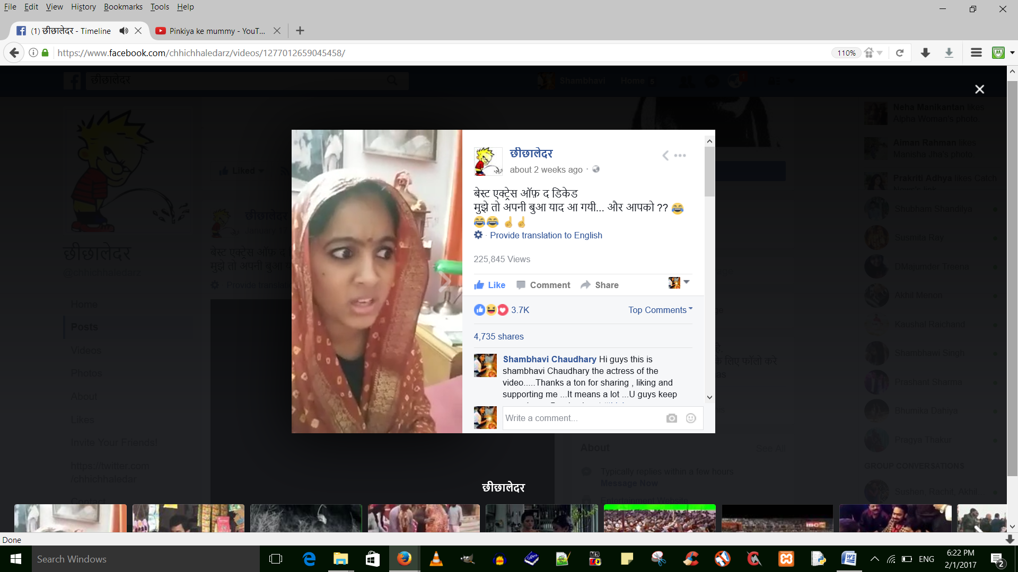

**2 lakhs views**

Contact:

Shambhavi-9620067183

Youtube channel: #think crazy

https://www.youtube.com/channel/UCnk1P6KgKykBkLhbMj6ocMg